**LCOM2**

There are several LCOM “lack of cohesion of methods” metrics.

LCOM1, LCOM2, LCOM3, LCOM4 and LCOM5.

m number of procedures (methods) in class

a number of variables (attributes) in class

mA number of methods that access a variable (attribute)

sum(mA) sum of mA over attributes of a class

LCOM2 = 1 - sum(mA)/(m*a)

LCOM2 equals the percentage of methods that do not access a specific attribute averaged over all attributes in the class. If the number of methods or attributes is zero, LCOM2 is undefined and displayed as zero.

LCOM2 varies between 0 (high cohesion) and 1 (no cohesion).

Class

B

A

Methods

Fields

LCOM2 = 1 – ((2 + 1) / 2 * 2)

= 0,25

*Ndepend isimli bir ticari uygulamada LCOM2 değeri 0,8’den büyük sınıflar sorunlu kabul ediliyor. Bunun dışında bir değer bulamadım. Zaten bizim uygulamamızda kullanıcı eşik değeri kendisi ayarlayabilecek.*

<http://www.aivosto.com/project/help/pm-oo-cohesion.html>

<http://www.ndepend.com/docs/code-metrics>

**CBO**

Number of classes to which a class is coupled.

* Method calls
* Accessing fields
* Pass as parameter
* Return from function

A, B, C are classes.

Acbo = 1

Bcbo = 0

Ccbo = 2

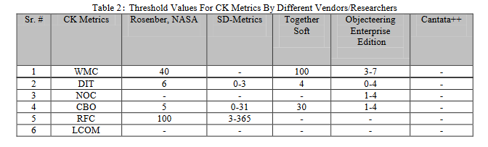

<https://arxiv.org/ftp/arxiv/papers/1204/1204.4909.pdf> akademik makalesinde yayınlanmış eşik değerleri

<http://www.aivosto.com/project/help/pm-oo-ck.html>

<http://www.virtualmachinery.com/sidebar3.htm>